Micrometers and Calipers

الميكروميتر والقدمة ذات الورانية

 | Micrometers | Calipers
Accuracy | 0.0001" | 0.001"
Types of Measurements | Outside Measurements | Inside, Outside & Depth Measurements

Micrometer and caliper comparisons

Accuracy
Micrometers are more accurate.
A typical micrometer is accurate to 0.0001″ and a caliper is only accurate to 0.001″.
This makes a micrometer 10x more accurate than a caliper.

2- Caliper

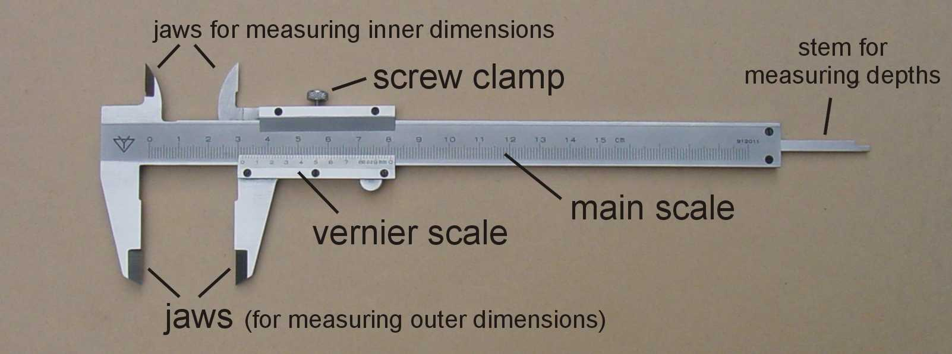

Measurement Reading Technique For Caliper
In order to read the measurement readings from vernier caliper properly, you need to remember two things before we start. For example, if a vernier caliper output a measurement reading of 2.13 cm, this means that:
- The main scale contributes the main number(s) and one decimal place to the reading (E.g. 2.1 cm, whereby 2 is the main number and 0.1 is the one decimal place number)

- The vernier scale contributes the second decimal place to the reading (E.g. 0.03 cm)

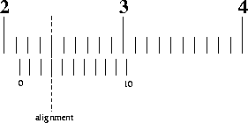
Let’s examine the image of the vernier caliper readings above. We will just use a two steps method to get the measurement reading from this:
- To obtain the main scale reading: Look at the image above, 2.1 cm is to the immediate left of the zero on the vernier scale. Hence, the main scale reading is 2.1 cm
- To obtain the vernier scale reading: Look at the image above and look closely for an alignment of the scale lines of the main scale and vernier scale. In the image above, the aligned line correspond to 3. Hence, the vernier scale reading is 0.03 cm.
In order to obtain the final measurement reading, we will add the main scale reading and vernier scale reading together. This will give 2.1 cm + 0.03 cm = 2.13 cm.

Use the following formula:
Obtained reading= Main scale reading + Vernier scale reading

Let’s go through another example to ensure that you understand the above steps:
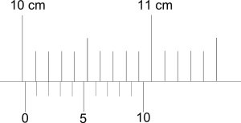
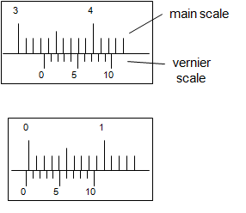
Main scale reading: 10.0 cm (Immediate left of zero)
Vernier scale reading: 0.02 cm (Alignment of scale lines)
Measurement reading: 10.02 cm
:

